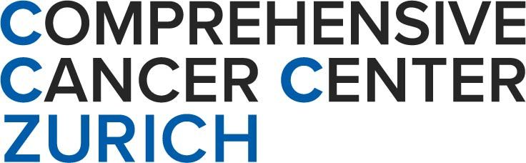 | 


Zurich 2026 Central Nervous System Metastasis Conference
February 12–13, 2026 | University Hospital Zurich (USZ)
Hosted by CCCZ & EORTC

Program Committee
Emilie Le Rhun, PD. Dr. med., Dep. of Medical Oncology and Hematology, University Hospital Zurich
Matthias Preusser, Univ.-Prof. Dr., Medical University Vienna, Austria
Matthias Guckenberger, Prof. Dr. med., Dep. of Radiooncology, University Hospital Zurich

Abstract
Abstract Title:
Authors (underline the presenting author):
Institution and Department:
University, City, Country:
E-mail of presenting author:

Background: Text
Material and Methods: Text
Results: Text
Conclusion: Text

Max. 500 words, please structure your abstract using the provided sections.
Please submit your abstract by e-mail to emilie.lerhun@usz.ch
Deadline for submissions: 15 January 2026
Selected abstracts will be presented in oral form or e-posters that will be shared to the registered participants

